Conditional probability
Bernoulli Trials

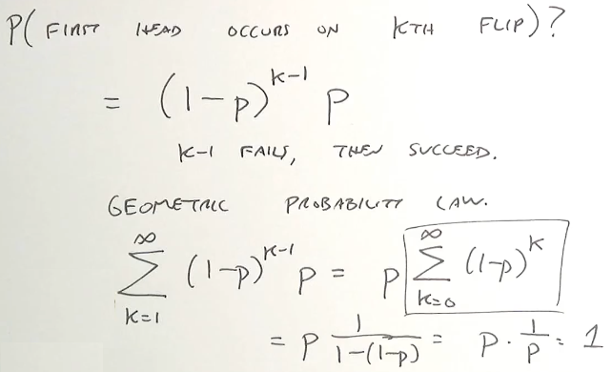
Bernoulli's Theorem
If we don’t know whether the coin is fair, we can keep flipping the coin, and then divide number of successes (k) by number of flips (n).
The question is how big the n needs to be to get a good estimate.
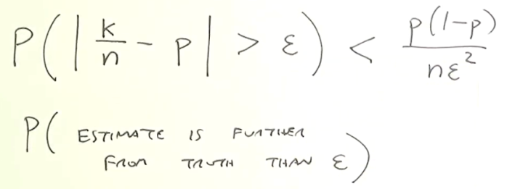
k = heads
n = number of flips
p = true probability

Main idea: probability of my estimate to be further from truth than ε
This number is getting smaller as the number of trials grows.
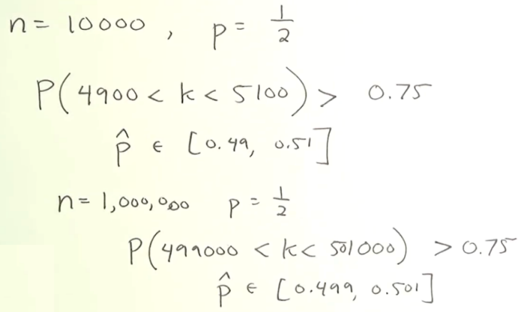

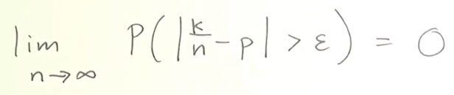

Gambler’s fallacy: trying predict a particular outcome based on previous trials. The coin has no memory, even with fair coin, you can get a pretty long string oh heads in a row, and the next flip still has P = 1/2 !

Expectation
Expected value – the average value weighted by the P of all possible outcomes ( = mean of the P distribution).
Note: this is NOT the most likely value.
μ =

flip a coin 3 times
X = number of heads
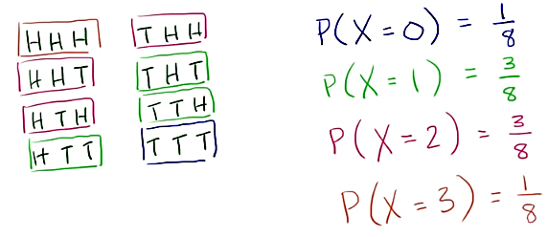
Expected value:
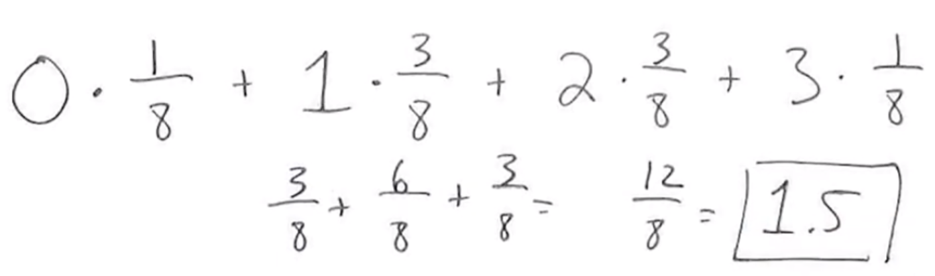

This is a probability distribution for a random variable X.
Uniform distribution – when all values are equally likely

Another example: we want to bet 1 chip on red number of the roulette, you can either gain another chip (1) or loose yours (-1). What’s the expected value of winning?
Random variable B, values 1 and -1
P(B=1) = 18/37 = 0.486486
P(B=-1) = 19/37 = 0.513514
E(B) = 1∙18/37 + (-1)∙19/37 =-1/37 = -0.027027

Random search

Probability for events NOT equally likely
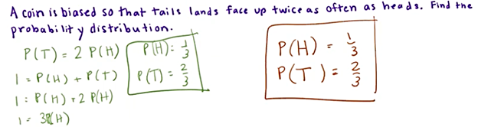
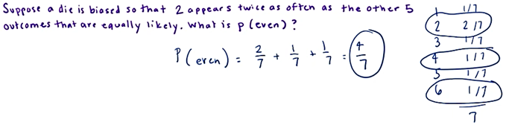

Probability Mass Function
p_{X}^{(x)} = little p _{big X} ^{(little x)} = P(X=x) (probability of random variable X having outcome x)

Uniform random variable - rolling a die
p_{X}⁽¹⁾=p_{X}⁽²⁾=p_{X}⁽³⁾=...

Bernoulli random variable - flip a coin
p_{X}⁽⁰⁾ = 1-p
p_{X}⁽¹⁾ = p

Geometric random variable - flip a coin until get heads
p_{X}⁽¹⁾ = p
p_{X}⁽²⁾ = (1-p)p
p_{X}⁽³⁾ = (1-p)²p
...

Binomial random variable - k successes in n trials
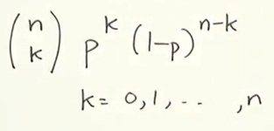
p_{X}^{(k)} =

Poisson random variable - events that occur randomly at continuous times (eg. Customers visiting a store)
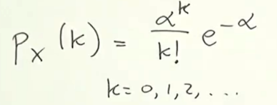
α is an average of events in an interval

Expectations:
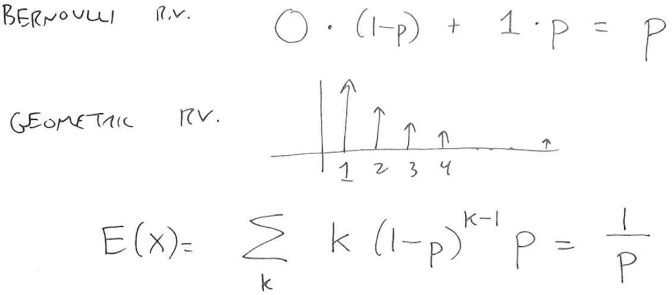
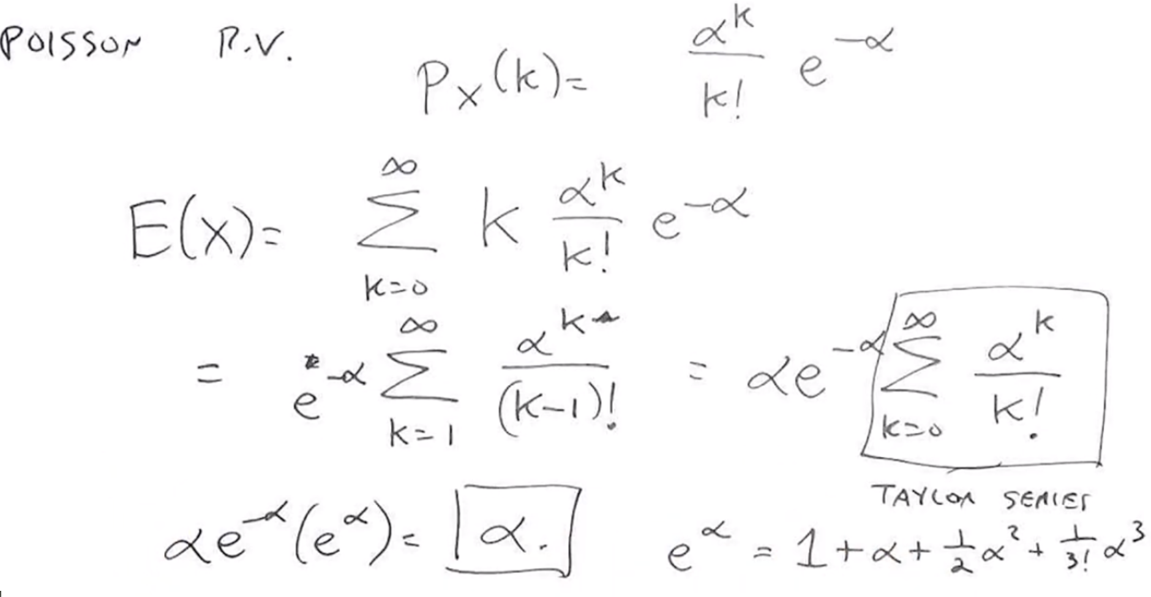

Simpson’s paradox
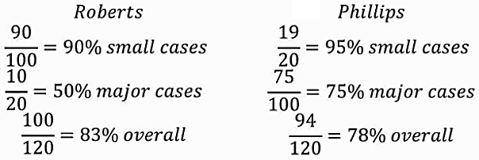
Philips has smaller overall even though he won more small and major cases. Major cases are harder to win. Be careful averaging across different conditions!

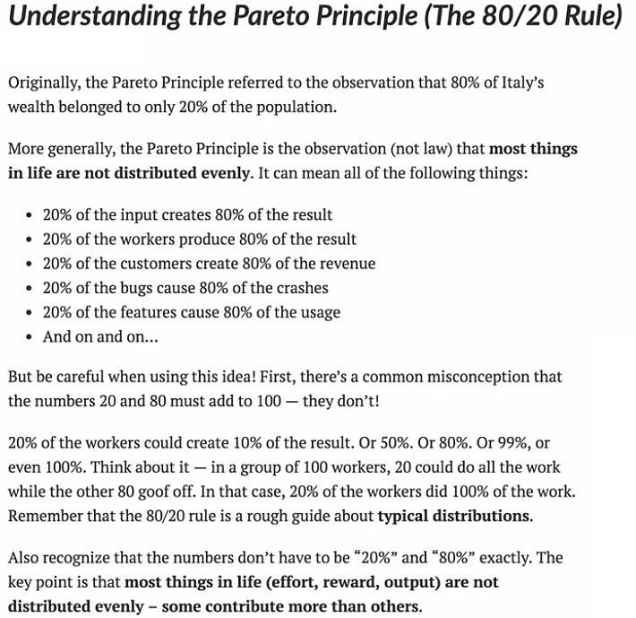
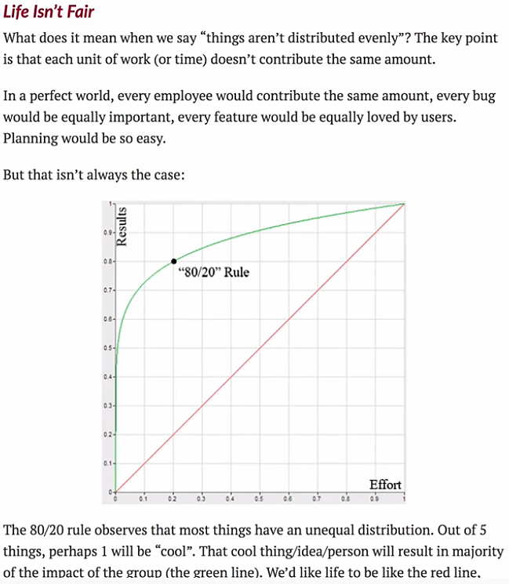

Statistical Significance Tests – module scipy.stats
Statistical significance means that the result that was produced has a reason behind it, it was not produced randomly, or by chance.
Hypothesis is an assumption about a parameter in population.
Null Hypothesis assumes that the observation is not stastically significant.
Alternate Hypothesis assumes that the observations are due to some reason. Its alternate to Null Hypothesis.

One tailed test
When our hypothesis is testing for one side of the value only, it is called "one tailed test". Eg. for the null hypothesis: "the mean is equal to k", we can have alternate hypothesis:
"the mean is less than k", or:
"the mean is greater than k"
Two tailed test
When our hypothesis is testing for both side of the values. Eg. for the null hypothesis: "the mean is equal to k", we can have alternate hypothesis: "the mean is not equal to k"
In this case the mean is less than, or greater than k, and both sides are to be checked.

Alpha value is the level of significance. Eg. how close to extremes the data must be for null hypothesis to be rejected. It is usually taken as 0.01, 0.05, or 0.1.
P value tells how close to extreme the data actually is. P value and alpha values are compared to establish the statistical significance.
If p value <= alpha we reject the null hypothesis and say that the data is statistically significant. otherwise we accept the null hypothesis.

T-Test
T-tests are used to determine if there is significant deference between means of two variables. and lets us know if they belong to the same distribution. It is a two tailed test.
The function ttest_ind() takes two samples of same size and produces a tuple of t-statistic and p-value.

# Find if the given values v1 and v2 are from same distribution:
from scipy.stats import ttest_ind
v1 = np.random.normal(size=100)
v2 = np.random.normal(size=100)
res = ttest_ind(v1, v2)
print(res) # Ttest_indResult(statistic=0.40833510339674095, pvalue=0.68346891833752133)

If you want to return only the p-value, use the pvalue property:
...
res = ttest_ind(v1, v2).pvalue
print(res) # 0.68346891833752133

KS-Test
KS test is used to check if given values follow a distribution. The function takes the value to be tested, and the CDF as two parameters. A CDF can be either a string or a callable function that returns the probability. It can be used as a one tailed or two tailed test. By default it is two tailed. We can pass parameter alternative as a string of one of two-sided, less, or greater.
from scipy.stats import kstest
# Find if the given value follows the normal distribution:
v = np.random.normal(size=100)
res = kstest(v, 'norm')
print(res) # KstestResult(statistic=0.047798701221956841, pvalue=0.97630967161777515)

Statistical Description of Data
In order to see a summary of values in an array, we can use the describe() function.
It returns the following description:
- number of observations (nobs)
- minimum and maximum values = minmax
- mean
- variance
- skewness
- kurtosis

from scipy.stats import describe
v = np.random.normal(size=100)
res = describe(v)
print(res)
_________________________________
DescribeResult(
nobs=100,
minmax=(-2.0991855456740121, 2.1304142707414964),
mean=0.11503747689121079,
variance=0.99418092655064605,
skewness=0.013953400984243667,
kurtosis=-0.671060517912661
)

Normality Tests (Skewness and Kurtosis)
Normality tests are based on the skewness and kurtosis.
Skewness: A measure of symmetry in data. For normal distributions it is 0.
If it is negative, it means the data is skewed left.
If it is positive it means the data is skewed right.
Kurtosis: A measure of whether the data is heavy or lightly tailed to a normal distribution.
Positive kurtosis means heavy tailed.
Negative kurtosis means lightly tailed.
The normaltest() function returns p value for the null hypothesis: "x comes from a normal distribution".

import numpy as np
from scipy.stats import skew, kurtosis
v = np.random.normal(size=100)
print(skew(v)) # 0.11168446328610283
print(kurtosis(v)) # -0.1879320563260931

# Find if the data comes from a normal distribution
from scipy.stats import normaltest
v = np.random.normal(size=100)
print(normaltest(v))
# NormaltestResult(statistic=4.4783745697002848, pvalue=0.10654505998635538)

